SQL Exercise

1. SELECT * FROM salesman;

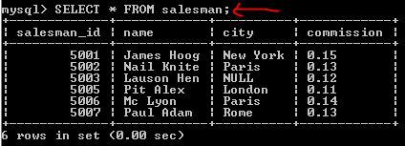

1. SELECT name, commission FROM salesman;

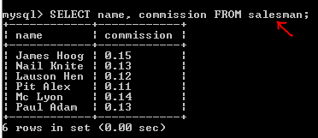

1. SELECT name, city FROM salesman WHERE city = 'Paris';

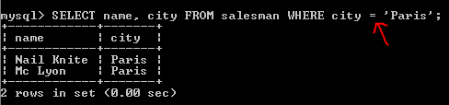

1. SELECT salesman_id, name, city, commission FROM salesman WHERE commission > 0.10 AND commission < 0.12;

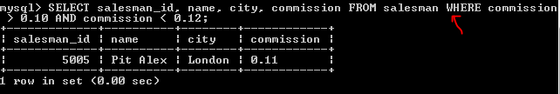

1. SELECT * FROM salesman WHERE city in ('Paris', 'Rome');

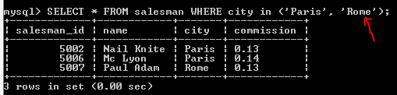

1. ..
2. SELECT * FROM salesman WHERE city NOT LIKE 'Paris' AND city NOT LIKE 'Rome';

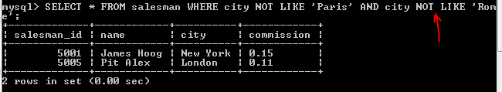

1. SELECT * FROM salesman WHERE commission BETWEEN 0.12 AND 0.14;

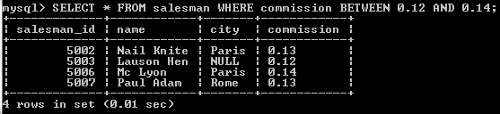

1. SELECT * FROM salesman WHERE name LIKE ‘[A-K]%’;

DOESNT WORK

1. SELECT * FROM salesman WHERE name NOT LIKE ‘[A-L]%’;

NOT WORKING

1. SELECT * FROM salesman WHERE name LIKE ‘N__L%’;

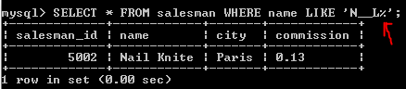

12

SELECT CONCAT(commission, ‘%’) AS commission, salesman_id, name, city FROM salesman;

Exercise 2

1. SELECT ord_date, salesman_id, ord_no, purch_amt FROM orders;

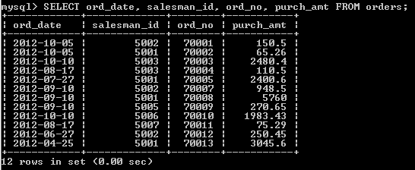

1. SELECT DISTINCT salesman_id, ord_no FROM orders;

NOT WORKING

1. SELECT ord_no, ord_date, purch_amt FROM orders WHERE salesman_id = 5001;

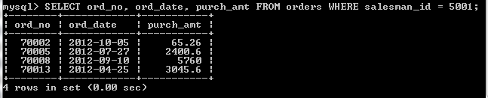

1. SELECT * FROM orders WHERE (ord_date != '2012-09-10' AND salesman_id < 5005) OR purch_amt < 1000;

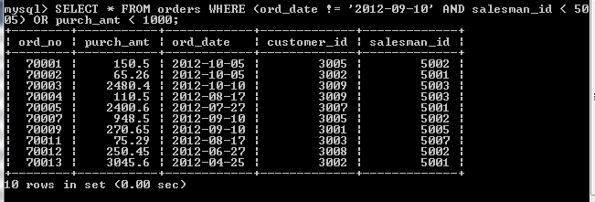

5

SELECT * FROM clt6.orders WHERE purch_amt < 1000

SELECT * FROM clt6.orders WHERE ord_date < '2012-10-01';

SELECT * FROM clt6.orders WHERE customer_id BETWEEN 3003 AND 3007;

6

SELECT * FROM orders WHERE ord_date = '2012-10-05' OR customer_id > 3005 AND purch_amt < 1000 ORDER BY ord_no DESC;

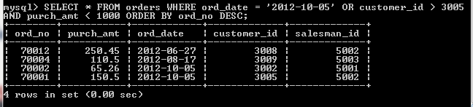

7

??

??

8

SELECT * FROM orders WHERE purch_amt BETWEEN 500 AND 4000 AND purch_amt NOT IN (948.5, 1983.43);

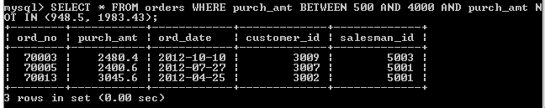

9

SELECT SUM(purch_amt) FROM clt6.orders;

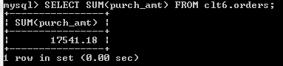

10

SELECT AVG(purch_amt) FROM clt6.orders;

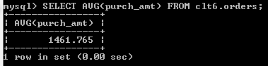

11

SELECT COUNT(salesman_id) FROM clt6.orders;

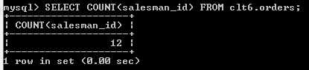

12

SELECT MAX(purch_amt) FROM clt6.orders;

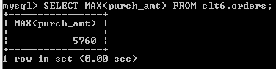

13

SELECT MIN(purch_amt) FROM clt6.orders;

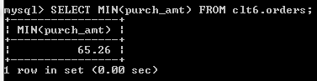

14

SELECT customer_id, MAX(purch_amt) FROM clt6.orders GROUP BY customer_id;

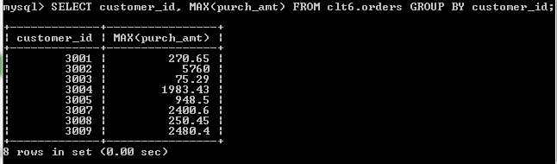

15

SELECT customer_id, ord_date, purch_amt FROM clt6.orders WHERE ord_date = '2012-09-10' ORDER BY purch_amt DESC;

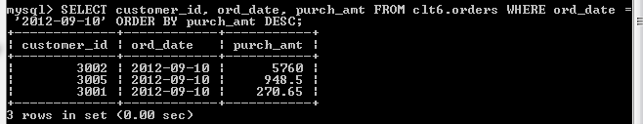

16

SELECT MAX(purch_amt), salesman_id FROM clt6.orders WHERE ord_date = '2012-08-17';

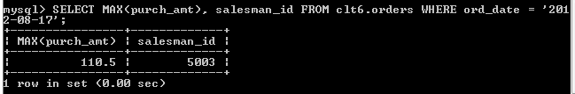

17

SELECT customer_id, MAX(purch_amt), ord_date FROM clt6.orders WHERE purch_amt > 2000 GROUP BY customer_id;

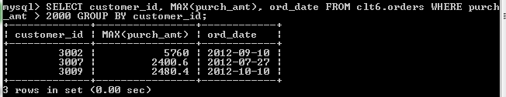

18

SELECT customer_id, MAX(purch_amt), ord_date FROM clt6.orders WHERE purch_amt BETWEEN 2000 AND 6000 GROUP BY customer_id LIMIT 0, 1000;

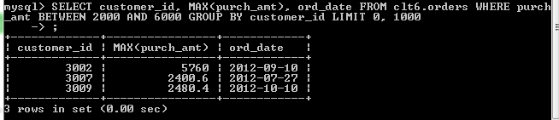

19

SELECT customer_id, MAX(purch_amt), ord_date FROM clt6.orders WHERE (purch_amt BETWEEN 2000 AND 3000) OR (purch_amt BETWEEN 5760 AND 6000) GROUP BY customer_id;

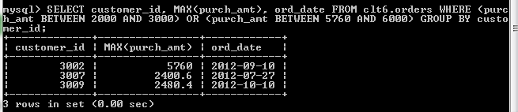

20

SELECT customer_id, MAX(purch_amt) FROM clt6.orders WHERE customer_id BETWEEN 3002 AND 3007 GROUP BY customer_id;

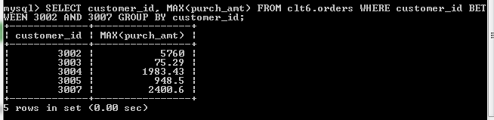

21

SELECT customer_id, purch_amt FROM clt6.orders WHERE customer_id BETWEEN 3002 AND 3007 AND purch_amt > 1000 GROUP BY customer_id;

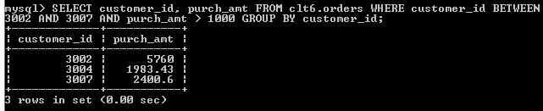

22

SELECT salesman_id, MAX(purch_amt) FROM clt6.orders WHERE salesman_id BETWEEN 5003 AND 5008 GROUP BY purch_amt;

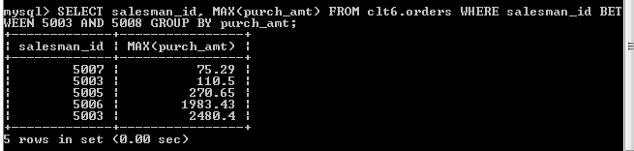

23

SELECT COUNT(ord_date) FROM clt6.orders WHERE ord_date = '2012-08-17';

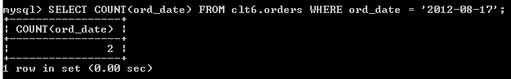

24

SELECT COUNT(salesman_id) FROM clt6.orders WHERE salesman_id IS NOT NULL;

Paper said to count CITY?

25

SELECT ord_date, COUNT(salesman_id) FROM clt6.orders GROUP BY ord_date;

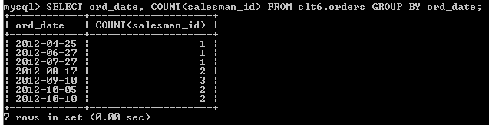

26

SELECT

CONCAT('For ',

order_date,

' there were ',

order_count,

' orders') AS 'Order Count'

FROM

(SELECT

ord_date AS order_date, COUNT(ord_no) AS order_count

FROM

clt6.orders

GROUP BY ord_date) AS SUBQUERY

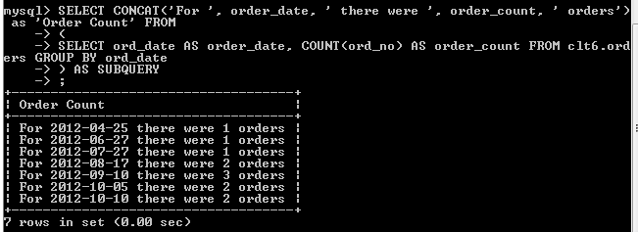

27

SELECT * FROM clt6.orders ORDER BY ord_no;

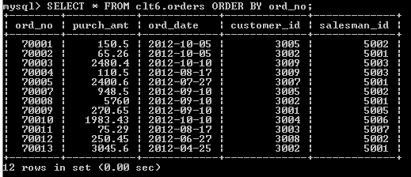

28

SELECT * FROM clt6.orders ORDER BY ord_date DESC;

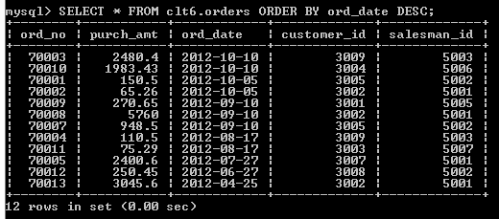

29

SELECT * FROM clt6.orders ORDER BY ord_date, purch_amt DESC;

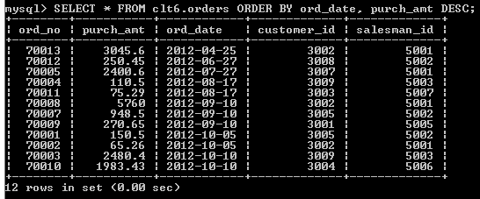

30

SELECT

salesman_id as 'Salesman ID',

ord_date as 'Order Date',

MAX(purch_amt) as 'Max Purchase Amount'

FROM clt6.orders

GROUP BY ord_date

ORDER BY salesman_id, ord_date;

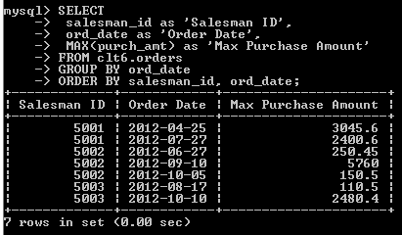

31

SELECT customer_id AS 'Customer ID',

COUNT(customer_id) AS 'Number of Orders',

MAX(purch_amt) AS 'Biggest Purchase'

FROM clt6.orders

GROUP BY customer_id;

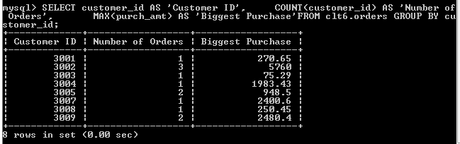

Exercise - Customer table

1

SELECT * FROM clt6.customer WHERE grade = 200;

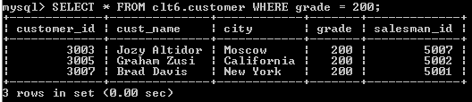

2

SELECT * FROM clt6.customer WHERE grade > 100;

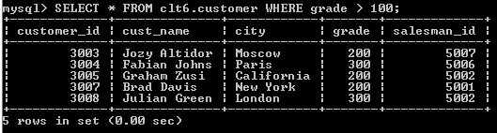

3

SELECT * FROM clt6.customer

WHERE city = 'New York'

AND grade > 100;

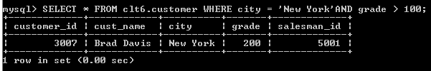

4

SELECT * FROM clt6.customer

WHERE city = 'New York'

OR grade > 100;

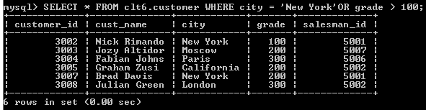

5

SELECT * FROM clt6.customer

WHERE city = 'New York'

OR NOT grade > 100;

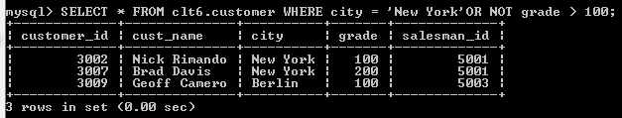

6

SELECT * FROM clt6.customer

WHERE NOT (city = 'New York' OR grade > 100);

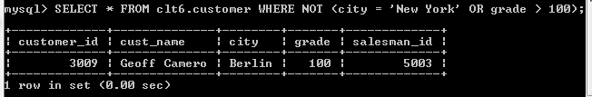

7

SELECT * FROM clt6.customer

WHERE customer_id IN (3007, 3008, 3009);

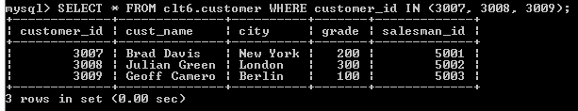

8

SELECT * FROM clt6.customer

WHERE grade IS NULL;

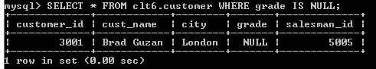

9

SELECT * FROM clt6.customer

WHERE grade IS NOT NULL;

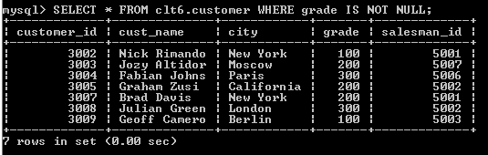

10

SELECT COUNT(cust_name) FROM clt6.customer;

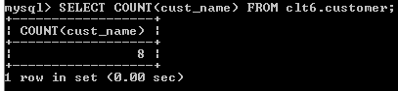

11

Not sure what grade to look for

SELECT *Count*(cust_name)   
FROM   clt6.customer   
WHERE  grade >= 200;12SELECT   city       AS 'City',   
         *Max*(grade) AS 'Highest Grade'   
FROM     clt6.customer   
GROUP BY city;

12

SELECT

city, MAX(grade)

FROM

clt6.customer

GROUP BY city;

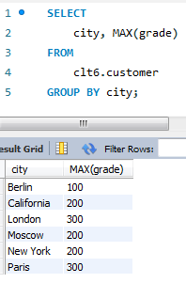

13

SELECT

customer_id, cust_name, city, grade

FROM

clt6.customer

ORDER BY customer_id;

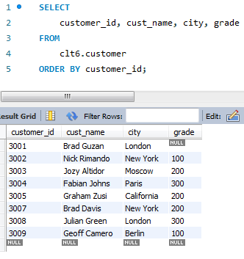

SQL – Join Exercises

1

SELECT salesman.city AS 'city',salesman.NAME AS 'Salesman',   
       customer.cust_name AS 'Customer'   
FROM   clt6.salesman   
       INNER JOIN clt6.customer using (city);

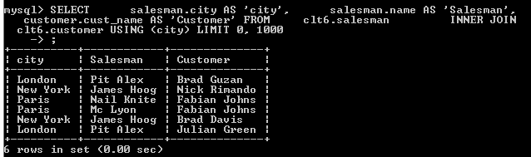

2

SELECT orders.ord_no,orders.purch_amt,customer.cust_name,customer.city   
FROM   clt6.orders,clt6.customer   
WHERE  clt6.orders.customer_id = clt6.customer.customer_id   
       AND purch_amt BETWEEN 500 AND 2000;

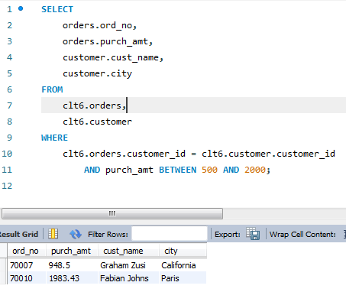

3

SELECT customer.cust_name,salesman.NAME   
FROM   clt6.customer   
       LEFT OUTER JOIN clt6.salesman using (salesman_id);

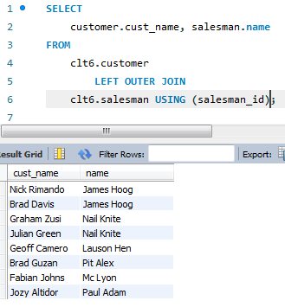

4

SELECT customer.cust_name   
FROM   clt6.customer,clt6.salesman   
WHERE  salesman.salesman_id = customer.salesman_id   
       AND customer.salesman_id IS NOT NULL   
       AND salesman.commission > 0.12;

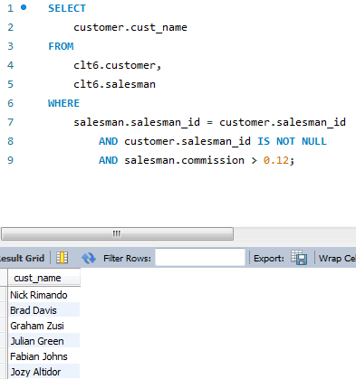

5

SELECT customer.cust_name   
FROM   clt6.customer,clt6.salesman   
WHERE  salesman.salesman_id = customer.salesman_id   
       AND customer.salesman_id IS NOT NULL   
       AND customer.city != salesman.city   
       AND salesman.commission > 0.12;

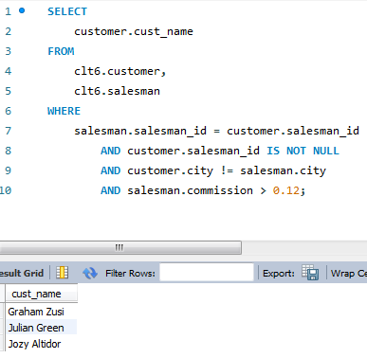

6

SELECT orders.ord_no,orders.ord_date,orders.purch_amt,customer.cust_name,   
       salesman.NAME AS 'Salesman Name',salesman.commission   
FROM   clt6.orders,clt6.customer,clt6.salesman   
WHERE  orders.customer_id = customer.customer_id   
       AND orders.salesman_id = salesman.salesman_id

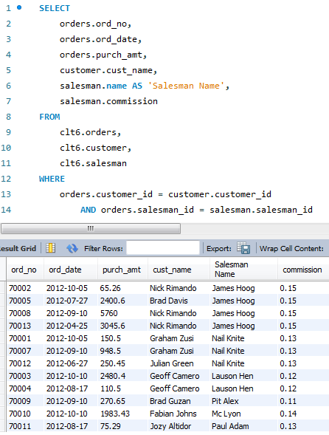

7

SELECT customer.customer_id,salesman.city,orders.salesman_id   
FROM   clt6.orders,clt6.customer,clt6.salesman   
WHERE  customer.customer_id = orders.customer_id   
       AND salesman.city = customer.city   
       AND ( orders.salesman_id = customer.salesman_id   
             AND customer.salesman_id = salesman.salesman_id )

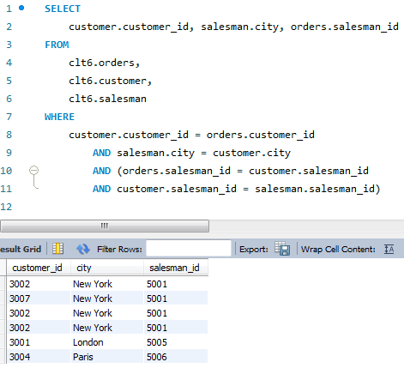

8

SELECT customer.customer_id,customer.cust_name AS 'Customer Name',   
       salesman.NAME AS 'Salesman Name'   
FROM   clt6.customer   
       LEFT OUTER JOIN clt6.salesman   
                    ON customer.salesman_id = salesman.salesman_id   
ORDER  BY customer.customer_id

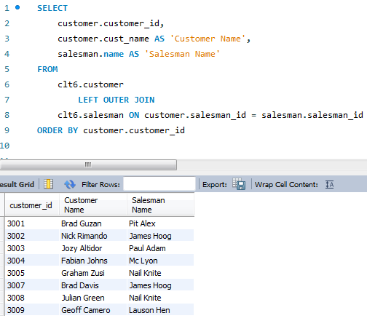

9

SELECT customer.customer_id,customer.cust_name AS 'Customer Name',   
       salesman.NAME AS 'Salesman Name',customer.grade   
FROM   clt6.customer,clt6.salesman   
WHERE  customer.salesman_id = salesman.salesman_id   
       AND grade < 300   
ORDER  BY customer.customer_id

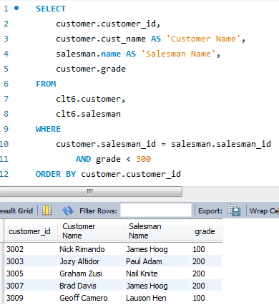

10

SELECT customer.cust_name,customer.city,orders.ord_no,orders.ord_date,   
       orders.purch_amt,   
       salesman.NAME AS 'Salesman Name',salesman.commission   
FROM   clt6.customer,clt6.salesman,clt6.orders   
WHERE  orders.customer_id = customer.customer_id   
       AND orders.salesman_id = salesman.salesman_id

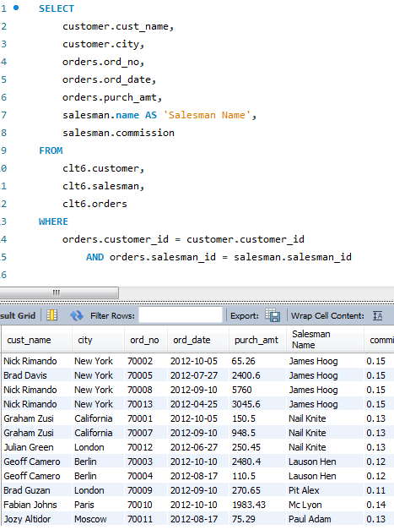

11

12

13

SELECT orders.ord_no,customer.cust_name,salesman.commission   
FROM   clt6.customer,clt6.salesman,clt6.orders   
WHERE  customer.customer_id = orders.customer_id   
       AND salesman.salesman_id = orders.salesman_id   
       AND customer.grade > 200

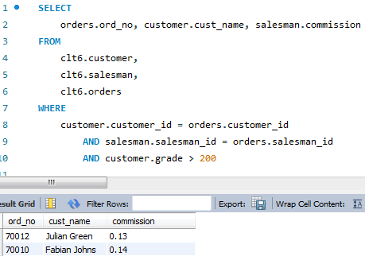

SQL Union Exercises

1

SELECT customer.cust_name,customer.city   
FROM   clt6.customer   
WHERE  city = 'London'   
UNION   
SELECT salesman.NAME,salesman.city   
FROM   clt6.salesman   
WHERE  city = 'London'

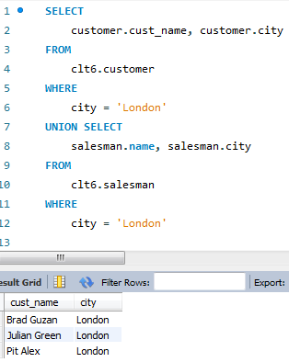

2

SELECT DISTINCT salesman.name, salesman.city FROM clt6.salesman

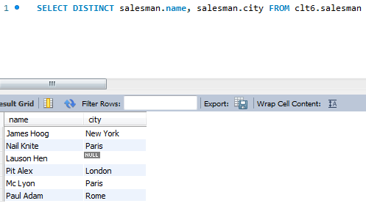

3

SELECT salesman.NAME   
FROM   clt6.salesman   
UNION   
SELECT customer.cust_name   
FROM   clt6.customer

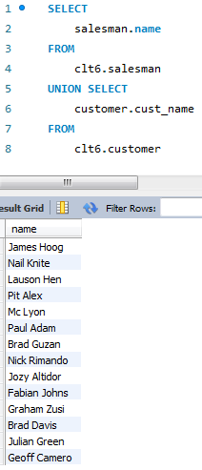

4

SELECT salesman.salesman_id,salesman.NAME,orders.ord_date,   
       *Max*(orders.purch_amt) AS 'MAX, MIN'   
FROM   clt6.salesman,clt6.orders   
WHERE  orders.salesman_id = salesman.salesman_id   
GROUP  BY orders.ord_date   
UNION   
SELECT salesman.salesman_id,salesman.NAME,orders.ord_date,*Min*(orders.purch_amt)   
FROM   clt6.salesman,clt6.orders   
WHERE  orders.salesman_id = salesman.salesman_id   
GROUP  BY orders.ord_date   
ORDER  BY ord_date

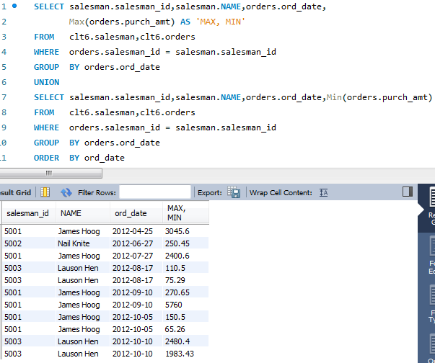

5

SELECT salesman.salesman_id,salesman.NAME,orders.ord_date,orders.ord_no,   
       *Max*(orders.purch_amt) AS 'MAX, MIN'   
FROM   clt6.salesman,clt6.orders   
WHERE  orders.salesman_id = salesman.salesman_id   
GROUP  BY orders.ord_date   
UNION   
SELECT salesman.salesman_id,salesman.NAME,orders.ord_date,orders.ord_no,   
       *Min*(orders.purch_amt)   
FROM   clt6.salesman,clt6.orders   
WHERE  orders.salesman_id = salesman.salesman_id   
GROUP  BY orders.ord_date   
ORDER  BY ord_no

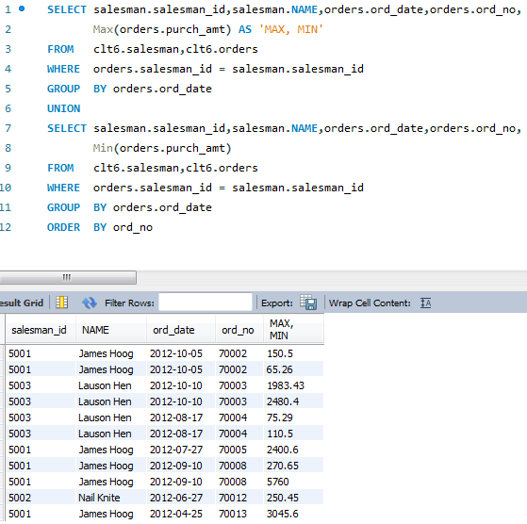

6

SELECT salesman.salesman_id,salesman.NAME   
FROM   clt6.salesman,clt6.customer   
WHERE  customer.salesman_id = salesman.salesman_id   
       AND salesman.city != customer.city   
UNION   
SELECT salesman.salesman_id,salesman.NAME   
FROM   clt6.salesman,clt6.customer   
WHERE  customer.salesman_id = salesman.salesman_id   
       AND salesman.city = customer.city

